Zadanie 5 i 6
$ curl http://localhost:5000/hello/
% Total % Received % Xferd Average Speed Time Time Time Current
Dload Upload Total Spent Left Speed
100 74 100 74 0 0 23329 0 --:--:-- --:--:-- --:--:-- 24666<!doctype html>
<title>Hello from Flask</title>

<h1>Hello, World!</h1>

vdi-terminal@MX1-Prog-008 MINGW64 ~
$ curl http://localhost:5000/hello/Michał
% Total % Received % Xferd Average Speed Time Time Time Current
Dload Upload Total Spent Left Speed
100 76 100 76 0 0 23869 0 --:--:-- --:--:-- --:--:-- 25333<!doctype html>
<title>Hello from Flask</title>

<h1>Hello Micha!</h1>
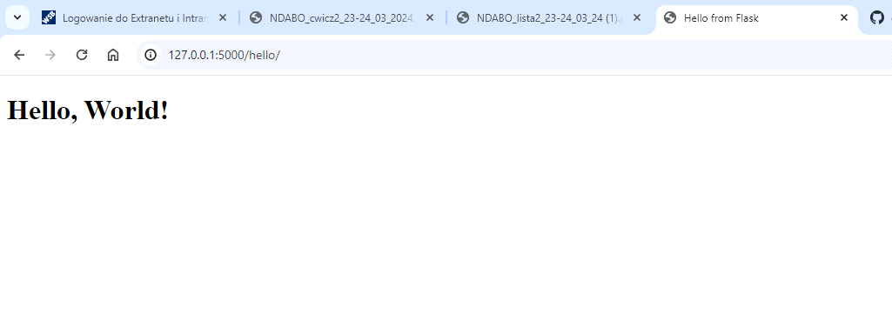
Zadanie 9
Pomimo, że zapowiadało się obiecująco, coś poszło na końcu nie tak.

$ make pylint
bash: make: command not found

